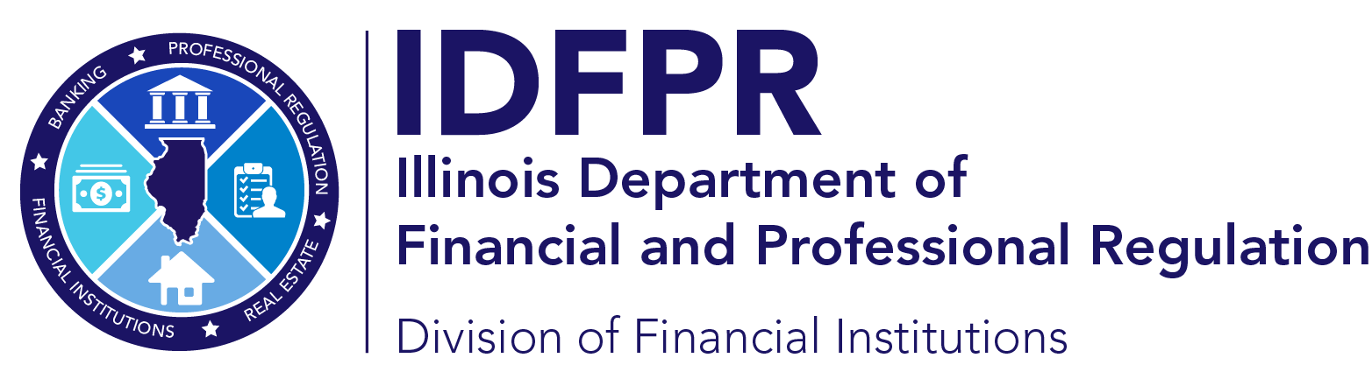 idfpr.illinois.gov
JB PRITZKER
Governor
MARIO TRETO JR.
Secretary
FRANCISCO MENCHACA
Director

COLLECTION AGENCY COMPANY APPLICATION CHECKLIST
Documents for All Applicants
New Application ($1350) fee __________
Application Form (submitted via portal), including: __________
- Ownership information (all direct and indirect owners holding 10% or more interest)
- Listing of all states where applicant holds license, including disciplinary record
Registration of Assumed Name with SoS (if applicable) __________
Certificate of Good Standing from SoS __________
Business Organization documents __________
Business Plan __________
Organizational Chart __________
PH-COL - Personal Employment History/Disclosures/Certifying Statement for each owner/officer __________
FS-COL - Financial Statement/Certifying Statement (may submit balance sheet in addition) __________
Additional Documents for Applicants that are not exclusively Debt Buyers
$25,000 Bond __________
EL-COL - Employee Identity Listing/Certifying Statement __________
TR-COL - Trust Account Financial Report/Certifying Statement __________

