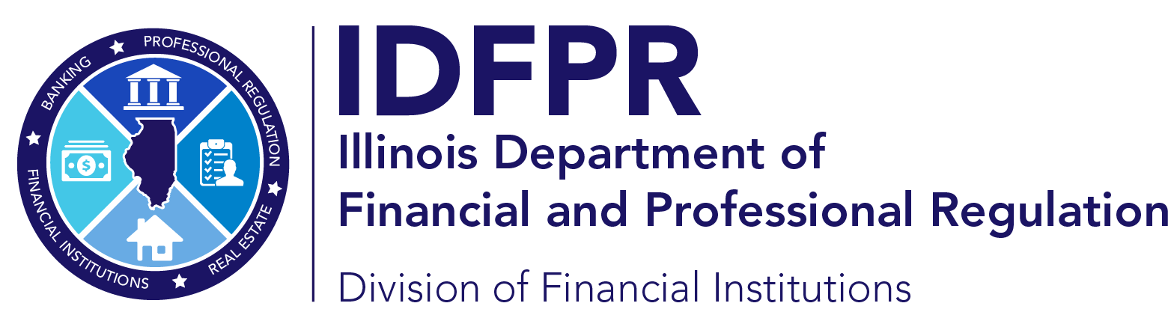 idfpr.illinois.gov
JB PRITZKER
Governor
MARIO TRETO JR.
Secretary
FRANCISCO MENCHACA
Director

COLLECTION AGENCY LICENSE CHANGES

How To Submit A Change Of Company Name Or Addition Of DBA

- Send email to fpr.consumercredit@illinois.gov including:
  - Letter explaining the change including license number and the new name.
  - Evidence that the new name has been updated on the Business Registration with the Secretary of State or an updated Certificate of Good Standing showing the new name.
  - Updated surety bond or surety bond rider reflecting new name (not necessary for addition of DBA)
______________________________________________________________________________

How To Submit Change Of Address For Company License
- Log into Illinois online portal
  - All active and formerly active licensees already have login information assigned for the online portal. If your company does not have its login information, please reach out to fpr.consumercredit@illinois.gov to request it
- Change address in online portal
- Upload updated surety bond rider to online portal and email to fpr.consumercredit@illinois.gov
______________________________________________________________________________

How To Submit Change Of Address For Branch License
- Send notification of change of branch address by email to fpr.consumercredit@illinois.gov – Include:
  - Collection agency name
  - License number
  - Prior address
  - New address
______________________________________________________________________________
How To Submit Notification Of Change Of Ownership
- If less than 50% of direct or indirect ownership is changing
  - Send notification of change of ownership by email to fpr.consumercredit@illinois.gov
  - Include:
    - PH-COL form for any new owners
    - Updated organizational chart
- If more than 50% of direct or indirect ownership is changing
  - Submit new application for licensure via the Illinois online portal
______________________________________________________________________________
How To Surrender License
- Send notification of surrender of license by email to fpr.consumercredit@illinois.gov
- Include:
  - License number(s)
  - Name of licensee
  - Effective date of surrender
  - Reason for surrender

